CH 304 - MOMENTUM TRANSFER
Hours per week : 04 I.A.Marks : 25
Total Hours : 50 Exam Marks : 100
Review of fluid statics - Fluid pressure variation of pressure with height - Hydrostatic equation - Barometric equation. Measurement of fluid pressure – Manometers, types of Fluids - shear stress and shear rate relationship. Types of flow - streamline, laminar & turbulent. Concept of momentum transfer. 8 hr
Basic equations of fluid flow - Continuity, Mechanical energy balance equation, Euler’s and Bernoulli’s equations. Modified equations for real fluids with correction factors. Momentum balance equation. Laminar flow through non-circular conduits, losses due to sudden expansion and contraction etc. Pipe line flow problems laminar and turbulent flow. Basic theory of turbulence - boundary layer theory. Velocity distribution equation in turbulent regions of flow. 12 hr
Flow of compressible fluid - sonic velocity, Mach. No., critical pressure ratio - flow through convergent and divergent section, Flow through nozzles. 10 hr
Transportation and metering of fluids - pipes, fitting and valves. Measurement of liquid and gas rates by orifice, venturi, rotameters and pitot tubes etc. Channels, weirs and notches. Pumps, compressors and blowers - Rotary. Reciprocatory, centrifugal and air lift pumps. Performance characters of pumps and blowers. 10 hr
Introduction to unsteady state flow - Time to empty the storage tank of different shapes.
Dimensional analysis and similitude - Dimensionless number - significance of numbers like Reynolds, Froude etc. Rayleigh's and Buckingham pi - methods. 10 hr
Reference Books:
1. McCabe.W.L. "Unit operation of Chemical Engineering". 5th Ed. Mc Graw Hill, NewYork, 1996.
2. Coulson and Richardson. Chemical Engineering Vol 1. ELBS, Program and
edn. 1973.
- Bansal R.K. “ Fluid mechanics and Hydraulic machines”
REVIEW OF FLUID STATICS
What is fluid mechanics?
The engineering science of fluid mechanics has been developed through an understanding of fluid properties, the application of the basic laws of mechanics and thermodynamics and orderly experimentation.
The behaviour of fluids is important to process engineering. An understanding of fluid is essential, not only for accurately treating problems on the movement of fluid through pipes, pumps and all kinds of process equipment but also for study of heat flow and the many separation operations that depend on diffusion and mass transfer.
The branch of engineering science that has to do with the behaviour of fluids is called fluid mechanics.
Fluid mechanics has two branches: fluid statics which treats fluids in the equilibrium state of no shear stress, and fluid dynamics, which treats fluids when portion of fluid are in motion relative to other parts.
To decide what we mean by the word “fluid”, first we have to consider the idea of shear stress. It is easiest to discuss shear stress in comparison with tensile stress and compressive stress.
In Figure 1.1(a) a rope is holding up a weight. The weight exerts a force, which tends to pull the rope apart. A stress is the ratio of the applied force to the area over which it is exerted. Thus the stress in the rope is the force exerted by the weight divided by the cross-sectional area of the rope. The force which tries to pull things apart is called a tensile force, and the stress it causes is called a tensile stress.
In Figure 1.1(b) a steel column is holding up a weight. The weight exerts a force, which tends to crush the column. This kind of force is called a compressive force, and the stress in the column, the force divided by the cross-sectional area of the column, is called a compressive stress.
In Figure 1.1(c) some glue is holding up a weight. The weight exerts a force that tends to pull the weight down the walls and thus to shear the glue. This force, which tends to make one surface slide parallel to an adjacent surface, is called a shear force, and the stress in the glue, the force divided by the area of the glue joint, is called Shear stress.
In our attempt to differentiate between fluids and solids, we can now say that solids are substances, which can permanently resist very large shear forces. When subjected to a shear force solids move a short distance (elastic deformation), thereby setting up internal shear stresses, which resist the external forces, and then they stop moving. Materials that obviously are fluids cannot permanently resist a shear force, no matter how small. When subjected to a shear force, fluids start to move and keep on moving as long as the force is applied.
100 Kg
Figure 1.1 (a)
100 Kg
Steel Column
Figure 1.1 (b)
Glue
Figure 1.1 (c)
100 Kg
A fluid is a substance that deforms continuously when subjected to a shear stress, no matter how small that shear stress may be.
Density: Density is a characteristic property of matter.
Density is defined as the mass per unit volume of a substance.
ρ = m/v
The S.I. unit for density is kg/m³. The units g/cc are also used commonly, especially in chemistry. The relative density, also called specific gravity of a substance is the ratio of its density to the density of pure water at 4ºC. The density of water at 4ºC is 1000kg/m³.
Density of the substance
Relative density or Specific gravity = -------------------------------------
Density of water

For any given substance at a fixed temperature, a graph of mass versus volume produces a linear relationship. The slope yields the density of the substance.
Empty specific gravity bottle
Empty specific gravity bottle + substance
Empty specific gravity bottle + water
Figure 1.2. Determination of Specific gravity of a liquid
The specific volume is the reciprocal of density, that is the volume occupied by unit mass of fluid.
Experimentally the specific gravity of a substance (liquid) can be obtained by following the steps given below
- Weigh empty specific gravity bottle (pycnometer), let the weight be w₁.
- Weigh pycnometer filled with the liquid , let the weight be w₂.
- Weigh pycnometer filled with water, let the weight be w₃.
- Find the specific gravity of the liquid as (w₂ – w₁)/(w₃ – w₁) i.e., ratio of weight of liquid to weight of water for same volume. Refer Figure 1.2.

Pressure: Imagine a closed container with air inside. Air, as a gas, is composed of molecules that can be imagined as round elastic balls. Molecules move in straight lines until they collide with neighbouring molecules or the container wall. Molecules of gas hitting the wall impose a force on the wall. The amount of this impact force per area of the container inner walls is called pressure. The mathematical definition of pressure can be written as
F
P=------
A
where F is the force of impact of molecules on the walls and A is the area of the walls. The unit for pressure in the SI system is the Pa (Pascal) and it is name after the famous French scientist who clarified principles related to pressure measurements. Strictly speaking, the Pa is the only valid unit. However, there are some other pressure-units, which are still in use: bar, atm., and Torr. For example, the pressure at sea level is 101300 Pa at standard temperature and the most common name for this specific pressure is an atmosphere or atm. The closest match to the atmosphere is 1 bar = 100000 Pa. The ratios between different units are given in Table 1.1.
Table 1.1 Ratios between different pressure units
Pressure Unit | Pa | Bar | Atm | Torr
Pa | 1 | 0.00001 | 9.869x10⁻⁶ | 7.501x 10⁻³
Bar | 100000 | 1 | 9.869x10⁻¹ | 750.1
Atm | 101325 | 1.01325 | 1 | 760
Torr | 113.22 | 0.001333 | 1.316x10⁻³ | 1

It is important to understand that pressure defined above is a property of gases. In the case of liquids the pressure at the certain position in liquid is created by the weight of the fluid column (remember that as you dive deeper into a ocean, pressure is high). The pressure imposed by the height of water is called hydrostatic pressure and is directly proportional to the height of the fluid above and its density. The mathematical definition of hydrostatic pressure is
P = ρgh
where h is the height of the fluid, ρ is fluid density and g is gravitational acceleration.

Vapour Pressure: The vapour molecules exert a partial pressure in the space, known as vapour pressure. The vapour pressure of a given fluid depends upon temperature and increases with it. When the pressure above a liquid equals the vapour pressure of the liquid, boiling occurs.

Compressible and Incompressible Fluids: If the density is little affected by moderate changes in temperature and pressure, the fluid is said to be incompressible, and if the density is sensitive to changes in these variables, the fluid is said to be compressible. liquids are considered to be incompressible and gases compressible.

Ideal Fluid and Ideal Gas: Ideal fluid is frictionless and incompressible but the perfect gas has viscosity and can therefore develop shear stresses and it is compressible according to ideal gas equation of state. (An equation of state is one, which relates between pressure, temperature and volume). Real gases below critical pressure and above the critical temperature tend to obey the perfect gas law.
Viscosity: Viscosity is the measure of resistance to flow. For example molasses and tar are highly viscous liquids; water and air have very small viscosities. The viscosity of a gas increases with temperature, but the viscosity of a liquid decrease with temperature.
The resistance of a fluid to shear stress depends upon its cohesion and upon its rate of transfer of molecular momentum. A liquid, with molecules much more closely spaced than a gas, has cohesive force much larger than a gas. Cohesion appears to be the predominant cause of viscosity in liquids; and since cohesion decreases with temperature, the viscosity also decreases. A gas, on the other hand, has very small cohesion forces. Most of its resistance to shear stress is the result of the transfer of molecular momentum and since molecular momentum increases with temperature, the viscosity of a gas also increases with temperature.
For ordinary pressures viscosity is independent of pressure and depends upon temperature only. For very great pressures, gases and most liquids have shown variations of viscosity with pressure.
The SI unit of viscosity is (N.s/m²) or (kg/m.s). The unit of viscosity in CGS system is (g/cm.s) also called poise.
The viscosities (μ) of liquids generally vary approximately with absolute temperature T according to:
ln μ= a - b ln T
Viscosity of gases increases with increase in temperature.
The viscosity (μ) of many gases is approximated by the formula:
μ = μ_{o}(T/T_{o})^{n}, in which T is the absolute temperature, μ_{o} is the viscosity at an absolute reference temperature T_{o}, and n is an empirical exponent that best fits the experimental data.
The viscosity of an ideal gas is independent of pressure, but the viscosities of real gases and liquids usually increase with pressure.
Viscosity of liquids is generally two orders of magnitude greater than gases at atmospheric pressure. For example, at 25ºC, μ_{water} = 1cP and μ_{air} = 1x10⁻² cP.

Kinematic viscosity: Kinematic viscosity is the ratio of viscosity to density γ = μ/ρ. Kinematic viscosity of gases varies with pressure because of change in density. The SI unit of kinematic viscosity is (m²/s) and the CGS unit is (cm²/s) called Stoke (St).

Newton’s law of viscosity: It states that the shear stress is directly proportional to velocity gradient or shear rate.
du
τ = μ -----
dy
The proportionality factor μ is called the viscosity or coefficient of viscosity.
Fluids are classified based on Newton’s law of viscosity as
- Newtonian – fluids which obey Newton’s law of viscosity
- Non-Newtonian – fluids which does not obey Newton’s law of viscosity.
Bingham
Pseudoplastic
Newtonian
Dilatant
Shear rate or Velocity gradient
Shear Stress τ
Figure 1.3 . Graphical representation of Newtonian and non-newtonian fluids
Non-Newtonian fluids can be again classified as follows
- Time independent (refer Figure 1.3 )
⇒ Bingham plastic fluids
⇒ Pseudoplastic fluids
⇒ Dilatant fluids
- Time dependent
⇒ Thixotropic fluids
⇒ Rheopectic fluids

Bingham fluids also called Bingham plastics, resist a small shear stress indefinitely, but flow easily under large shear stresses. One may say that at low stresses the viscosity in infinite and that at higher stresses the viscosity decreases with increasing velocity gradient. Examples are bread dough, toothpaste, jellies, and some slurries. Good toothpaste should be a Bingham fluid, so that it can be easily squeezed out of the tube but will not drip off the toothbrush as water or honey would.
Pseudoplastic fluids show a viscosity that decreases with increase in velocity gradient. Examples are most slurries, mud, polymer solutions, solutions of natural gums, and blood.
Dilatant fluids show a viscosity that increases with increase in velocity gradient. They are uncommon, but starch suspensions, quick sand etc., behave in this way.
So far, we have assumed that the curve of τ vs. du/dy in not a function of time.
⇒ The viscosity can remain constant with time, in which case the fluid is called time independent.
⇒ The viscosity can decrease with time, in which case the fluid is called thixotropic.
⇒ The viscosity can increase with time, in which case the fluid is called rheopectic.
A good paint should be thixotropic, so that in the container it will be very viscous and the pigment will not settle to the bottom, but when it is stirred, it will become less viscous and can be easily brushed onto a surface. In addition, the brushing should temporarily reduce the viscosity, so that the paint will flow sideways and fill in the brush marks (called levelling in the paint industry); then, as it stands, its viscosity should increase, so that it will not form drops and run down the wall. A good motor oil should be Pseudoplastic, so that in the bearing, where the value of du/dy is high, it will offer little frictional resistance and so that at all the gaskets and joints, where the value of du/dy is low, it will be viscous and not leak through.

Pascal’s law: Pascal’s law states that the pressure or intensity of pressure at a point in a static fluid is equal in all directions.

Proof: Consider a very small prism in the fluid at rest and assume that its thickness is ds. Suppose that the pressures in three directions of the prism are P₁, P₂ and P₃. Under the action of the pressure forces the prism is in equilibrium and therefore the forces in horizontal and vertical directions must be balanced.
B
C
A
A’
B’
C’
P₂
P₃
P₁
θ
ds
θ
Horizontal component
Vertical component
Figure 1.4. Forces on a element
The forces acting on the element are
- pressure forces normal to the surfaces
- weight of the element in the vertical direction
let the angle 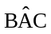 = θ
Resolving the forces in the horizontal direction
P₂ .BC.ds – P₁. AB. Sin θ. ds = 0 → (1)
From the figure 1.4
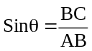
Substituting the value of Sin θ in equation (1)
P₂ .BC.ds – P₁. AB.(BC/AB). ds = 0
⇒ P₂ = P₁
Resolving the forces in vertical direction
P₃. AC . ds – P₁ . AB.ds. Cos θ - ½ AC.BC.ds. ρ . g = 0
Since the element is very small the force due to its weight can be neglected and the above equation can be written as
P₃ . AC . ds – P₁ . AB.ds. Cos θ = 0→ (2)
From the figure 1.4
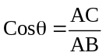
substituting the value of cos θ in the equation 2, we have
P₃ . AC . ds – P₁ . AB.ds. (AC/AB) = 0→ (2)
⇒ P₃ = P₁
∴ P₁ = P₂ = P₃
From this it can be concluded that the pressure at a point in a static fluid is same in all directions.
Pressure variations in static fluid
The laws of variation of pressure in a static fluid may be developed by considering variations along horizontal direction and along vertical direction.
Variations along horizontal direction
Consider a cylindrical body as shown in the figure. Select any two points A and B separated by a distance ‘L’ m in a horizontal plane on the body. Assume the axis is passing through the two points A and B. Let δa is the cross sectional area of the cylindrical body.
The forces acting in an axial direction at A and B are Pa . δa and Pb . δa.
δa
A
B
P_{A}
P_{B}
L
To find pressure variations along a horizontal line take force balance around the body
ie., Pa . δa - Pb . δa = 0 [note : When fluid is at equilibrium sum of forces must be equal to zero.]
∴ Pa = Pb
So, this proves that the pressure is constant in any cross section parallel to earth surface.
Variations along a vertical direction
Consider a vertical column of fluid as shown in figure. Let the cross-sectional area of the column be ‘S’ m². At a height ‘Z’ m from the base and let (P+dP) be the pressure at (Z+dZ) m. Assume the density of the fluid be ‘ρ’ kg/m³.
To find the pressure variations along the vertical line write the force balance around the volume S. dZ.
The three vertical forces acting on this are
- The force of gravity acting downward is ρ.S.dZ. g
- The force from pressure ‘P’ acting in the upward direction is P.S
Z m
dZ
S m²
P+dP
P
Z_{a}
Z_{b}
- The force from pressure ‘P+dP’ acting in downward direction is (P+dP). S
When the fluid is in equilibrium sum of the three forces must be equal to zero.
P.S – (P+dP).S- ρ . S. dZ.g = 0
Divide through out by ‘S’
P – P – dP - ρ. dZ. g = 0
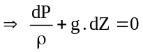→ (1)
The above equation cannot be integrated unless the variation of density with pressure is known.
Case i : Assuming density is constant with respect to pressure ie., the fluid is incompressible.
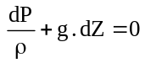
Integrating this equation gives, 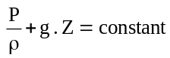
This equation is called hydrostatic equation.
The same equation can be integrated between the limits Z_{a} and Z_{b}
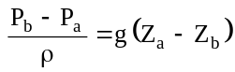
So, the pressure varies along the vertical line. As the depth increases pressure will also increase.
The above equation can be written as ΔP = ρ g h, where h is the height measured form the free surface.
Case ii. Assuming density is varying with respect to pressure.
Case a: Assuming the fluid obeys isothermal law.
For isothermal process, the density and pressure are related by the equation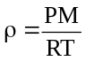, where P is pressure in N/m²
M is molecular weight of the fluid in kg/kgmole
T is absolute temperature in K and
R is universal gas constant = 8314.4 J/(kgmole K)
Consider equation (1)
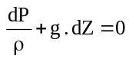
Substituting the value of ρ in the above equation, we have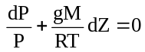
Integrating the above equation between the levels a and b on the assumption that T is constant, gives
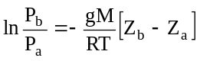
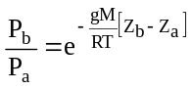
This equation is called barometric equation
We have
This can be written as 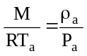
Therefore barometric equation can be written as 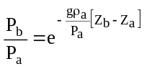 or 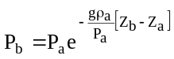

Case b : Assuming the fluid obeys Adiabatic law.
For adiabatic process the relation between pressure and density is given by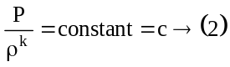, where k is ratio of specific heat constants ie., C_{p}/C_{v}.
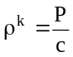⇒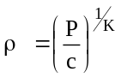
we know from equation (1)

substituting the value of ρ in the above equation gives
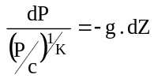⇒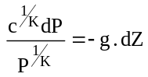
Integrating the above equation gives

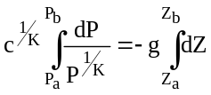
But from equation (2) 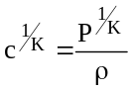
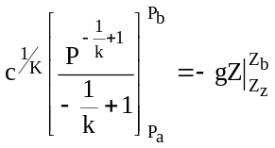
Substituting for ‘c^{1/K}’ in the above equation gives

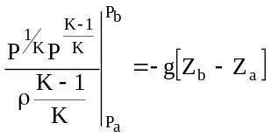
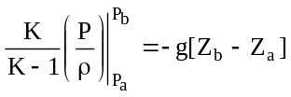
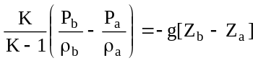
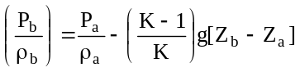
Multiplying both sides by ρ_{a}/P_{a}, gives
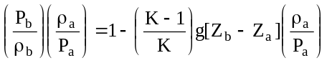
From equation (2) we have
Substituting for ρ_{a}/ρ_{b} in the above equation gives
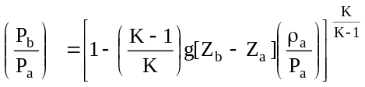
Pressure at a height Z_{b} m from Z_{a} is given by
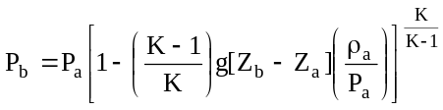
If datum is taken as Z_{a} = 0, where temperature, pressure and density are T_{o}, P_{o} and ρ_{o}
Then the above equation becomes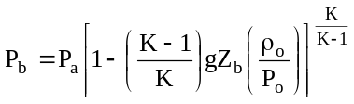
We have,
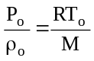
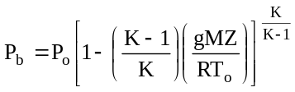
To find temperature at a height Z_{b}
We have from perfect gas law,
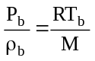
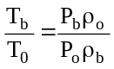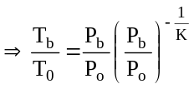
Substituting value of P_{b}/P_{o} gives
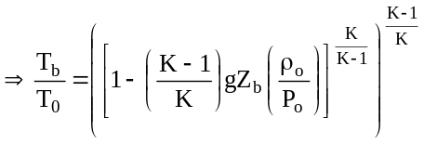
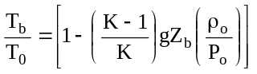⇒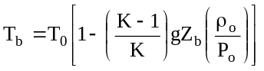
or
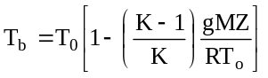

Temperature lapse rate: It is defined as the rate at which the temperature changes with elevation.
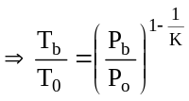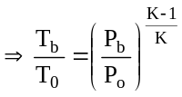
To obtain an expression for the temperature lapse rate, the temperature given by the above equation is differentiated with respect to Z_{b}
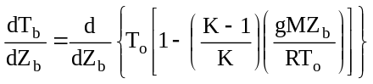
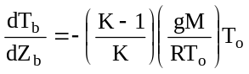
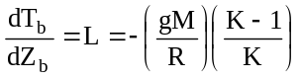

Note : 1. If ‘K’ is not given take, K = 1.4, at ideal conditions.
2. R = 8314.4 J/kgmole K
3. If adiabatic process is reversible it is known as Isentropic process.
Worked Examples :

1.1. Calculate the force acting on a 1.5m square base shown in the figure when the pressure guage reads 147KN/m².
Pressure intensity due to water =ρ.g.h}_{for water} = 1000 x 9.81 x 2
Water
Sp. gr =1
2m
1m
Oil
Sp. gr.= 0.8
Air
= 19620 N/m²
Pressure intensity due to oil = ρ.g.h }_{for oil}
= 800 x 9.81 x 1
= 7848 N/m²
Total pressure intensity = 147000 + 19620 + 7848
= 174468 N/m²

1.2. A rectangular vessel is 3.7 m long, 1.5m wide and 1.8m deep on its inside. There is water in it to a depth of 1.5m. Find the intensity of pressure on
- horizontal base of the vessel
- Longer side of the vessel at a point 0.6 m below the free surface.
- Shorter side of the vessel at a point 0.5 m above the horizontal base.
(i) Data : ΔP = ?
ρ = 1000 kg/m³.
1.5m
1.5m
1.8m
3.7m
Since the pressure does not vary in the horizontal plane, it is the same whether it is shorter side or longer side.
h = 1.5 m
- h = 0.6 m
- h = 1.5 – 0.5 = 1.0 m
The pressure at the bottom of the tank can be taken found out using the equation ΔP = ρ g h,
where ρ is the density of the fluid in the tank and h is the height of fluid column from measured from the free surface and g is the acceleration due to gravity
∴ ΔP = 1000 * 9.81 * 1.5
= 14715 N/m²
(ii) ΔP = 1000 * 9.81 * 0.6
= 5886 N/m²
(ii) ΔP = 1000 * 9.81 * 1
= 9810 N/m²

1.3. Find the head ‘h’ of water corresponding to an intensity of pressure of 981KN/m². Density of water is 1000kg/m³.
Data : ΔP = 981*10³ N/m².
ρ = 1000 kg/m³.
h = ?
we have ΔP = ρ g h ⇒ 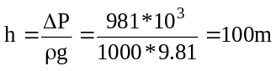
1.4. The pressure intensity at a point in a fluid is given 39.24 kN/m². Find the corresponding height of fluid, when the fluid is a) water and b) oil of specific gravity 0.9.
Data : (i) ΔP = 39.24 kN/m² = 39.24 * 10³ N/m²
ρ = 1000 kg/m³.
h = ?

(ii) ΔP = 39.24 kN/m² = 39.24 * 10³ N/m²
ρ = 900 kg/m³.
h = ?
(i) 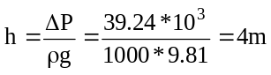
(ii) 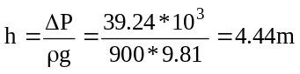
1.5. Oil of specific gravity 0.9 is contained in a vessel. At a point the height of oil is 40m. Find the corresponding height of water at the point.
Data : specific gravity of oil = 0.9
∴ density ρ = specific gravity of oil density of water = 0.9*100 = 900.
h_{Oil} = 40m
ΔP_{oil} = ρ g h |_{oil} = 900*9.81*40 = 353160 N/m² .
from the problem ΔP_{oil} = ΔP_{Water}
∴ 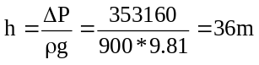

1.6. An open tank contains water upto a depth of 2m and above it an oil of specific gravity 0.9 for a depth of 1m. Find the pressure intensity at the interface of the two liquids, and at the bottom of the tank.
. Data : specific gravity of oil = 0.9
∴ density ρ = specific gravity of oil density of water = 0.9*100 = 900.
ΔP_{oil} = ρ g h |_{oil} = 900*9.81*1 = 8829 N/m² .
ΔP_{water} = ρ g h |_{water} = 1000*9.81*2 = 19620 N/m² .
ΔP_{Total} = ΔP_{Oil} + ΔP_{water} = 8829 + 19620 = 28449 N/m².
1.7. Determine the gauge and absolute pressure at a point, which is 2.0m below the free surface of water. Take atmospheric pressure as 10.143 N/cm².
Data : ρ_{water} = 1000 kg/m³
h = 2m
ΔP_{water} = ρ g h |_{water} = 1000*9.81*2 = 19620 N/m² (gauge pressure)
absolute pressure = 19620 + 10.143*10⁴ = 121050 N/m².

1.8. If the atmosphere pressure at sea level is 10.143 N/cm², determine the pressure at a height of 2500m assuming the pressure variation follows hydrostatic law and isothermal law. The density of air is given as 1.208kg/m³.
Data : P_{a} = 10.143 N/cm² = 10.143 *10⁴ N/m²
z_{b} = 2500m, z_{a} = 0, ρ_{a} = 1.208 kg/m³
- assuming hydrostatic law applies,
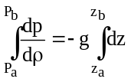
(P_{b} – P_{a}) = - ρ g (z_{b} – z_{b})
P_{b} = P_{a} - ρ g(z_{b} – z_{b}) = 10.143*10⁴ – 1.208*9.81*2500 = 71803.8 N/m²
(ii) assuming Isothermal law applies,
P_{b} = P_{a} * exp(-gρ_{a} (z_{b} – z_{b})/P_{a})
= 10.143*10⁴ * exp(-(9.81*1.028*2500)/(10.143*10⁴))
= 79107.394 N/m².

1.9. Calculate the pressure at a height of 7500m above sea level if the atmospheric pressure is 10.143N/cm² and temperature is 15ºC at the sea level, assuming (i) air is incompressible (ii) pressure variation follows isothermal law and (iii) pressure variation follows adiabatic law. Take the density of air at the sea level as 1.285 kg/m³. Neglect variation of g with altitude.
Data : P_{a} = 10.143 N/cm² = 10.143 *10⁴ N/m²
z_{b} = 7500m, z_{a} = 0, ρ_{a} = 1.285 kg/m³
- assuming hydrostatic law applies,
(P_{b} – P_{a}) = - ρ g (z_{b} – z_{b})
P_{b} = P_{a} - ρ g(z_{b} – z_{b}) = 10.143*10⁴ – 1.285*9.81*7500 = 6886.125 N/m²
(ii) assuming Isothermal law applies,
P_{b} = P_{a} * exp(-gρ_{a} (z_{b} – z_{b})/P_{a})
= 10.143*10⁴ * exp(-(9.81*1.285*7500)/(10.143*10⁴))
= 39935.247 N/m².
(iii) 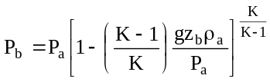
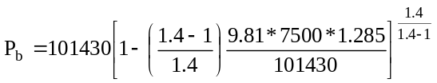
= 34311.995 N/m².

1.10. Calculate the pressure and density of air at a height of 4000m from sea level where pressure and temperature of air are 10.143N/cm² and 15ºC respectively. The temperature lapse rate is gives as 0.0065ºC/m. The density of air at sea level equal to 1.285kg/m³.
Data : P_{a} = 10.143 N/cm² = 10.143 *10⁴ N/m² , L = -0.0065ºC/m.
z_{b} = 4000m, z_{a} = 0, ρ_{a} = 1.285 kg/m³, T_{a} = 15ºC = 273+15 = 288 K.
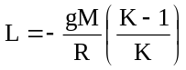
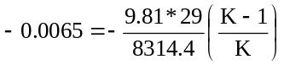
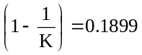⇒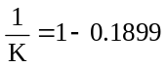= K=1.234
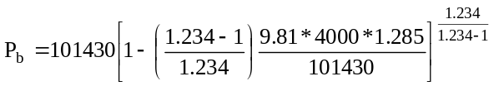
=60173.22 N/m².
For every 1m, the decrease in temperature is 0.0065K
∴ for 4000m the decrease in temperature is 0.0065*4000 = 26
∴ the temperature at an elevation of 4000m is 288-26 = 262K
We know 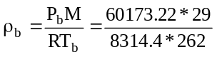= 0.801kg/m³.

1.11. An aeroplane is flying at an altitude of 5000m. Calculate the pressure around the aeroplane, given the lapse rate in the atmosphere as 0.0065ºK/m. Neglect variation of g with altitude. Take pressure and temperature at ground level as 10.143 N/cm² and 15ºC and density of air as 1.285 kg/m³.
Data : P_{a} = 10.143 N/cm² = 10.143 *10⁴ N/m² , L = -0.0065ºC/m.
z_{b} = 5000m, z_{a} = 0, ρ_{a} = 1.285 kg/m³, T_{a} = 15ºC = 273+15 = 288 K.
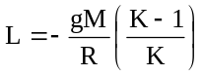
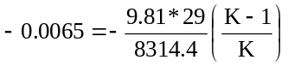
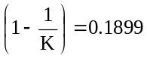⇒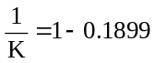= K=1.234
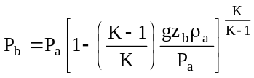
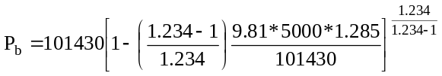
P_{b} = 52362.688 N/m².

1.12. The atmospheric pressure at the sea level is 101.3 KN/m² and temperature is 15ºC. Calculate the pressure at 8000m above seal level, assuming (i) isothermal variation of density, and (ii) adiabatic variation of pressure and density. Assume density of air as sea-level as 1.285kg/m³. Neglect variation of ‘g’ with altitude.
Data : P_{a} = 101.3 kN/m² = 101.3 *10³ N/m²
z_{b} = 8000m, z_{a} = 0, ρ_{a} = 1.285 kg/m³
(i) assuming Isothermal law applies,
P_{b} = P_{a} * exp(-gρ_{a} (z_{b} – z_{b})/P_{a})
= 101.3*10³ * exp(-(9.81*1.285*8000)/( 101.3*10³))
= 37433.28 N/m².
(iii) , Assuming K = 1.4
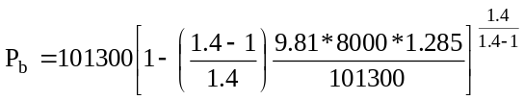= 31396.341 N/m².

1.13. The temperature of earth’s atmosphere drops about 5ºC for every 1000 m of elevation above the earth’s surface. If the air temperature at ground level is 15ºC and the pressure is 760 mm Hg, at what elevation is the pressure 380 mm Hg? Assume that the air behave as an ideal gas.
Data : P_{a} = 760 mm Hg = 101325 N/m² , L = -0.005ºC/m.
P_{a} = 380 mm Hg = (380/760)*101325 = 50662.5 N/m²
z_{b} = ? m, z_{a} = 0, ρ_{a} = 1.285 kg/m³, T_{a} = 15ºC = 273+15 = 288 K.
for every 1000 m the decrease in temperature is 5 ºC
∴for 1m the decrease in temperature is 0.005ºC
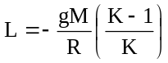
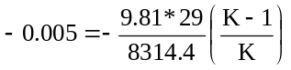
K=1.171
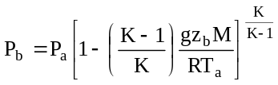
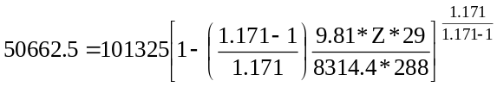
Z=5553.778m.

MANOMETRY (MEASUREMENT OF FLUID PRESSURE)

Pressure can be measured by allowing it to act on known cross-sectional area and opposing the pressure with a column of fluid or by a compressed spring. The first method of measuring pressure is called manometry. Manometers are the devices used for measuring of pressure at a point in a fluid by balancing the column of fluid by the same or another column of fluid. They are classified as
Simple manometers
Differential manometers
Simple Manometers: A simple manometer consists of a glass tube, having one of its end connected to a point, where the pressure is to be measured and other end remains open to atmosphere. Common types of simple manometers are
Piezometer or pressure tube
U- tube manometer
Piezometer: This is the simplest form of manometer used for measuring gauge pressures. One end of this is connected to the point where pressure is to be measured and other end is open to the atmosphere as shown in Figure. The rise of liquid, gives the pressure head at that point. If at a point A, the height of liquid say water is ‘h’ in piezometer tube, then the pressure at A is
h
Fluid a with density ρ_{a}
a
Figure 1.5. Piezometer

P_{a} = ρ_{a} . g. h

The piezometer will not work for negative gauge pressure, because air will flow into the container through the tube. It is also impractical for measuring large pressure, since the vertical tube would need to be very long.

Simple U tube manometer [to measure pressure at a point]: It consists of a glass tube bent in ‘U’ shape, one end of which is connected to point at which pressure is to be measured and other end remain open to the atmosphere. The tube generally contains mercury or any other liquid whose specific gravity is greater than the specific gravity of the liquid whose pressure is to be measured.
Let ‘A’ is the point at which pressure is to be measured. Let the datum line be B-B. Let h₁ be the height of the light liquid above the datum line, h₂ be the height of the heavy liquid above datum line, density of light liquid be ρ_{a} and ρ_{b} be the density of the heavy liquid.
To obtain the pressure at point a we start measuring the pressures at every point and resolve for the pressure at a. (refer figure 1.6)
Starting with point 1.
h₂
Fluid a with density ρ_{a}
a
Figure 1.7. Simple ‘U’ tube Manometer to measure pressure at a point. (Vacuum)
B
B
h₁
1
2
3
4
h₂
Fluid a with density ρ_{a}
Figure 1.6. Simple ‘U’ tube Manometer to measure pressure at a point.
B
B
h₁
1
2
3
4
1→P_{a}
2→P_{a} + ρ_{a} g h₁
The pressure at point 2 and 3 are same because the datum line is parallel to the earth’s surface.
∴ 3→ P_{a} + ρ_{a} g h₁
4→ P_{a} + ρ_{a} g h₁ - ρ_{b} g h₂ = 0, because point 4 is exposed to atmosphere.
Now solving for Pa will give
Pa = ρb g h₂ - ρa g h₁
Similar to the one solved above, we shall solve for measuring the negative gauge pressure (vacuum). (refer figure 1.7)
Starting with point 1.
1→P_{a}
2→P_{a} + ρ_{a} g h₁
3→ P_{a} + ρ_{a} g h₁+ ρ_{b} g h₂
The pressure at point 3 and 4 are same because the datum line is parallel to the earth’s surface.
4→ P_{a} + ρ_{a} g h₁ + ρ_{b} g h₂ = 0, because point 4 is exposed to atmosphere.
Now solving for Pa will give
P_{a} = - (ρ_{b} g h₂ + ρa g h₁)

‘U’ tube manometer [to measure pressure difference between two points]:
A ‘U’ tube manometer is shown in figure 1.8. It consists of a trasparent U-tube containing the fluid A whose pressure is to be measured and an immiscible fluid B of higher density. The limbs are connected to two points between which the pressure difference is required. The connecting leads should be completely full of fluid A.
R_{m}
Fluid a with density ρ_{a}
Figure 1.8. Simple ‘U’ tube Manometer to measure pressure difference
B
B
h₁
1
2
3
4
5
Manometric fluid b with density ρ_{b}
Z_{m}
The Pressure Pa is excerted in one arm of the U- tube and a pressure P_{b} in th other. As a result of the difference in pressure P_{a} – P_{b}, the meniscus in one branch of the U- tube is higher than in the other, and the vertical distance between the two meniscus R_{m} may be held to measure the difference in pressure.
To derive the relationship between P_{a} - P_{b} and R_{m}, we start with point 1.
1 →P_{a}
2 →P_{a} + ρ_{a} g h₁ = P_{a} + ρ_{a} g ( Z_{m} + R_{m} ) { since h1 = Zm + Rm, refer figure 1.8}
by principles of hydrostatics, pressure at point 2 = pressure at point 3
3 → P_{a} + ρ_{a} g ( Z_{m} + R_{m} )
4 → P_{a} + ρ_{a} g ( Z_{m} + R_{m} ) - ρ_{b} g R_{m}
5 → P_{a} + ρ_{a} g ( Z_{m} + R_{m} ) - ρ_{b} g R_{m} - ρ_{a} g Z_{m} = P_{b}
⇒ P_{a} – P_{b} = - ρ_{a} g ( Z_{m} + R_{m} ) + ρ_{b} g R_{m} + ρ_{a} g Z_{m}
⇒ P_{a} – P_{b} = g R_{m} (ρ_{b} - ρ_{a} )
This relationship is independent of the distances Z_{m} and the dimensions of the tube provided that pressure P_{a} and P_{b} are measured in the same horizontal plane.
Piezometer or pressure tube
U- tube manometer
: In this, one leg of the manometer is inclined in such a manner that for a small magnitude of R_{m} the meniscus in the inclined tube will move considerable distance along the tube. This distance R₁, is R_{m} divided by the sine of α, the angle of inclination. By making ‘α’ small, the magnitude of R_{m} is multiplied into a long distance R₁ and a large reading becomes equivalent to a small pressure difference.
To derive relationship between (P_{a} – P_{b} ) and R_{m} , we start from point 1
1 → P_{a}
2 → P_{a} + ρ_{f} g h₁
Pressure at point 3 is equal to pressure at point 2, from hydrostatic principles
3 → P_{a} + ρ_{f} g h₁
4 → P_{a} + ρ_{f} g h₁ - ρ_{m} g R_{m}
5 → P_{a} + ρ_{f} g h₁ - ρ_{m} g R_{m} - ρ_{f} g h₂ = P_{b}
By simplifying the above equation
P_{a} – P_{b} = ρ_{m} g R_{m} - ρ_{f} g h₁ + ρ_{f} g h₂
P_{a} – P_{b} = ρ_{m} g R_{m} + ρ_{f} g( h₂ - h₁ )
P_{a} – P_{b} = ρ_{m} g R_{m} + ρ_{f} g( -R_{m} )
P_{a} – P_{b} = g R_{m} (ρ_{m} - ρ_{f} )
From the figure
R_{m} = R₁ sin α
Substituting the value of R_{m} in the above equation gives
P_{a} – P_{b} = g R₁ sin α (ρ_{m} - ρ_{f} )
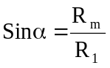
In this type of pressure gauge, it is necessary to provide an enlargement in the vertical leg so that the movement of the meniscus in the enlargement is negligible within the operating range of the instrument.
Fluid f with density ρ_{f}
1
2
α
R_{m}
h₂
h₁
R₁
Fluid m with density ρ_{m}
Figure 1.9. Inclined manometer
P_{a}
P_{b}
3
4
5
α
R_{m}
R₁
R_{m} = R₁ sin α

Differential manometer [Micro manometer, two fluid manometer , Well type of manometer]
For the measurement of smaller pressure differences, this type of manometer shown in the figure 1.10, called differential manometer is often used.
This manometer contains two liquids a and c which must be immiscible and whose densities are as nearly equal as possible. Enlarged chambers are inserted in the manometer, so that the position of the meniscus at point 2 and 6 does not change appreciably with changes in the reading R_{m}. Consequently the distance between points 1 and 2 may be considered equal to the distance between points 6 and 7. The same principle may be employed in developing the relationship between the reading of this type manometer and the pressure difference P_{a} – P_{b}, as the previous cases. The changes in pressure in passing through the series of points 1 to 7 are :
1
2
Fluid B with density ρ_{b}
Fluid A with density ρ_{a}
Figure 1.10. Micro manometer
P_{a}
7
P_{b}
3
4
Liquid c with density ρ_{c}
5
6
a
a
b
d
R_{m}
1 →P_{a}
2 →P_{a} + ρ_{b} g a
3 → P_{a} + ρ_{b} g a + ρ_{a} g b
Pressure at point 3 is equal to pressure at point 4, from hydrostatic principles
4 → P_{a} + ρ_{b} g a + ρ_{a} g b
5 → P_{a} + ρ_{b} g a + ρ_{a} g b - ρ_{c} g R_{m}
6 → P_{a} + ρ_{b} g a + ρ_{a} g b - ρ_{c} g R_{m} - ρ_{a} g d
7 → P_{a} + ρ_{b} g a + ρ_{a} g b - ρ_{c} g R_{m} - ρ_{a} g d - ρ_{b} g a = P_{b}
Simplifying the above equation we get,
P_{a} – P_{b} = ρ_{a} g (d – b) + ρ_{c} g R_{m}
From figure 1.10, b-d - Rm
∴ P_{a} – P_{b} = R_{m} g (ρ_{c} - ρ_{a} )
From this equation it follows that the smaller the difference (ρ_{c} - ρ_{a} ), larger will be the reading of R_{m} on the manometer for the given value of ΔP.

Inverted manometer:
It consists of an inverted ‘U’ tube containing a light liquid. The two ends of the tube are connected to the points whose difference of pressure is to be measured. It is used for measuring low-pressure differences. Figure 1.11 shows an inverted U tube manometer connected to two points A and B. Let the pressure at A is more than the pressure at B. Let h₁ be the height of liquid in left limb below the datum line B-B and h₂ be the height of liquid in right limb. R_{m} be the manometric reading. Let ρ_{a} and ρ_{b} be the density of liquid A and manometric liquid B respectively.
Starting from point 1:
1 → P_{a}
2 →P_{a} - ρ_{a} g h₁
Pressure at point 3 is equal to pressure at point 2, from hydrostatic principles
Figure 1.11. Inverted ‘U’ tube Manometer to measure low pressure differences
b
a
1
h₂
Fluid a with density ρ_{a}
h₁
3
3
R_{m}
h₁
B
B
2
4
5

3 → P_{a} - ρ_{a} g h₁
4 → P_{a} - ρ_{a} g h₁ + ρ_{b} g R_{m}
5 → P_{a} - ρ_{a} g h₁ + ρ_{b} g R_{m} + ρ_{a} g h₂ = P_{b}
Solving for P_{a} - P_{b}
P_{a} - P_{b} = ρ_{a} g h₁ - ρ_{b} g R_{m} - ρ_{a} g h₂
Substituting the value of h₁ in the above equation, we have
P_{a} - P_{b} = ρ_{a} g (R_{m} + h₂) - ρ_{b} g R_{m} - ρ_{a} g h₂
P_{a} - P_{b} = ρ_{a} g ( h₁ – h₂ ) –ρ_{b} g R_{m}
Worked Examples
1.14. Find the pressure of oil in a pipe line fitted with a pressure tube and reads a height of 1.5m of oil. Assume specific gravity of oil as 0.85.
Data : Density of oil ρ_{oil} = specific gravity oil * density of water
= 0.85*1000=850 kg/m³.
P_{oil} = ρ_{oil} g h = 850 * 9.81 * 1.5 = 12507.75 N/m²
1.15. A simple manometer is used to measure the pressure of water flowing in a pipe line. It’s right limb is opened to the atmosphere and left limb is connected to a pipe. The centre of the pipe is in level with that of the mercury in right limb. Determine the pressure in the pipe if the difference of mercury level in two limbs is 10cm. Densities of mercury and water are 13.6 * 10³ kg/m³ and 1000 kg/m³ respectively.
The data are represented in the figure.
The pressure at different points are written as
Water with density
1000 kg/m³
B
B
10 cm
1
2
3
Mercury with density
13600 kg/m³
1. P₁
2. P₁ + ρ_{w}gh
- P₁ + ρ_{w}gh
- P₁ + ρ_{w}gh- ρ_{m}gh =0

P₁ = gh[ρ_{m}-ρ_{w}]
=9.81*0.1*[13600-1000]
P₁= 1.236*10⁴ N/m²

1.16. A simple U tube manometer containing mercury is connected to a pipe in which a fluid of specific gravity of 0.8 and having vacuum pressure is flowing . The other end of the manometer is opened to the atmosphere. Find the vacuum pressure in the pipe if the difference of mercury level in the two limbs are 40 cm and the height of the fluid in the left limb from the centre of the pipe is 15 cm below.
The data are represented in the figure.
Fluid with specific gravity 0.8
B
B
40 cm
1
2
3
Mercury with density
13600 kg/m³
15 cm
4
The pressure at different points are written as
1. P₁
2. P₁ + ρ_{a}gh₁
- P₁ + ρ_{a}gh₁ +ρ_{m}gh₂
- P₁ + ρ_{a}gh₁ +ρ_{m}gh₂ =0
P₁ = -g[ρ_{m}h₂+ρ_{a}h₁]
= - 9.81*[13600*0.40 – 800*0.15]
P₁= - 54543.6 N/m²

1.17. The right limb of a simple U tube manometer containing mercury is open to the atmosphere, while the left limb is connected to a pipe in which a fluid of specific gravity 0.9 is flowing. The centre of the pipe is 12 cm below the level of mercury in the right limb. Find the pressure of the fluid in the pipe if the difference of mercury level in two limbs is 20cm.
The data are represented in the figure.
Fluid with specific gravity 0.9
B
B
h₁
1
2
3
Mercury with density
13600 kg/m³
h₂ = 20 cm
4
h₃ = 12 cm
From the figure
h₁ = h₂ – h₃
h₁ = 20 – 12 = 8 cm
h₁ = 0.08m.
The pressure at different points are written as
1. P₁
2. P₁ + ρ_{a}gh₁
- P₁ + ρ_{a}gh₁
- P₁ + ρ_{a}gh₁ - ρ_{m}gh₂ =0
P₁ = g[ρ_{m}h₂-ρ_{a}h₁]
= - 9.81*[13600*0.20 – 900*0.08]
P₁= 25976.88 N/m²

1.18. Two tubes running full with brine( sp. gr. 1.26) are connected to a differential mercury manometer. The connecting tubes are filled with water. The centre line of high pressure pipe is 180 cm lower in elevation than the centre line of the other pipe. If the mercury reading is 60 cm, what is the pressure difference in N/m².
The data are represented in the figure.
Let the distance between mercury level and the lower tube be (points 1- 4) a.
Brine with specific gravity 1.26
B
B
(60 – a) cm
1
2
3
Mercury with density
13600 kg/m³
R_{m} = 60 cm
4
a cm
5
180 cm
P₁
P₂
∴ the distance between points 1 and 2 is (60-a).
The pressure at different points are written as
1. P₁
2. P₁ + ρ_{b}*g * (0.60-a)
3. P₁ + ρ_{b}*g * (0.60-a)
4. P₁ + ρ_{b}*g * (0.60-a) - ρ_{m}*g * 0.60
5. P₁ + ρ_{b}*g * (0.60-a) - ρ_{m}*g * 0.60 - ρ_{b}* g * (0.180-a) = P₅
∴ P₁ – P₅ = ρ_{m}*g * 0.60 + ρ_{b}* g * (0.180-a)- ρ_{b}*g * (0.60-a)
P₁ – P₅ = ρ_{m}*g * 0.60 + ρ_{b}* g * 0.180 - ρ_{b}* g * a - ρ_{b}*g * 0.60 + ρ_{b}*g * a
Solving
P₁ – P₅ = ρ_{m}*g * 0.60 + ρ_{b}* g * 0.180 - ρ_{b}*g * 0.60
P₁ – P₅ = 13600*9.81 * 0.60 + 1260* 9.81 * 0.180 - 1260*9.81 * 0.60
P₁ – P₅ = 2224.908 + 80049.6 – 7416.36
P₁ – P₅ = 74858.148 N/m².

1.19. Determine the pressure difference in the figure given below.
The pressure at different points are written as
A
B
Water
Mercury with specific gravity 13.6
0.75m
0.5m
100m
1
2
3
4
5
1. P_{A}
2. P_{A}+ρ_{w}*g*(0.75+0.5+0.1)
3. P_{A}+ρ_{w}*g*(0.75+0.5+0.1)
4. P_{A}+ρ_{w}*g*(0.75+0.5+0.1) - ρ_{m}*g*0.1
5. P_{A}+ρ_{w}*g*(0.75+0.5+0.1) - ρ_{m}*g*0.1 - ρ_{w}*g*0.5 = P_{B}
P_{A} – P_{B}= ρ_{m}*g*0.1 + ρ_{w}*g*0.5 - ρ_{w}*g*1.35
P_{A} – P_{B}= 5003.1 N/m²
1.20. Determine (P_{A} – P_{B}) and (P_{A}- P_{c}) in the figure given and express them in kN/m².
A
B
C
1
2
3
4
5
6
7
8
9
10
Water
Mercury (sp.gr. 13.6)
Oil (sp.gr. 0.8)
Carbon tetra chloride (sp.gr. 1.6)
0.3m
0.1m
0.15m
0.08 m
0.3 m
0.4 m
The pressure at different points are written to find the difference between (P_{A}-P_{C}) as
1. P_{A}
2. P_{A} + ρ_{w}*g*0.3
3. P_{A} + ρ_{w}*g*0.3
4. P_{A} + ρ_{w}*g*0.3-ρ_{m}*g*0.1
5. P_{A} + ρ_{w}*g*0.3-ρ_{m}*g*0.1-ρ_{o}*g*0.15 = P_{c}
P_{A} – P_{C} = ρ_{m}*g*0.1 + ρ_{o}*g*0.15 - ρ_{w}*g*0.3
P_{A} – P_{C} = 13600*9.81*0.1 + 800*9.81*0.15 - 1000*9.81*0.3 = 11.5kN/m²
Continuing from point 5 till point 10 to obtain the difference between (P_{A} – P_{B})
6. P_{A} + ρ_{w}*g*0.3-ρ_{m}*g*0.1-ρ_{o}*g*0.15 = P_{c}
7. P_{A} + ρ_{w}*g*0.3-ρ_{m}*g*0.1-ρ_{o}*g*0.15 + ρ_{o}*g*(0.15+0.08)
8. P_{A} + ρ_{w}*g*0.3-ρ_{m}*g*0.1-ρ_{o}*g*0.15 + ρ_{o}*g*(0.23)
9. P_{A} + ρ_{w}*g*0.3-ρ_{m}*g*0.1-ρ_{o}*g*0.15 + ρ_{o}*g*(0.23)-ρ_{c}*g*0.3
10. P_{A} + ρ_{w}*g*0.3-ρ_{m}*g*0.1-ρ_{o}*g*0.15 + ρ_{o}*g*(0.23)-ρ_{c}*g*0.3 - ρ_{o}*g*0.4 = P_{B}
P_{A} – P_{B} = ρ_{m}*g*0.1+ρ_{o}*g*0.15 + ρ_{c}*g*0.3 + ρ_{o}*g*0.4 - ρ_{w}*g*0.3 - ρ_{o}*g*(0.23)
P_{A} – P_{B} = 13600*9.81*0.1+800*9.81*0.15 + 1600*9.81*0.3 + 800*9.81*0.4 - 1000*9.81*0.3 - 800*9.81*(0.23) ⇒ P_{A} – P_{B} = 17.61kN/m².
Fluid dynamics: Fluid dynamics is the study of fluids in motion relative to other parts.
Types of Flow: The flow patterns are classified in the following different categories.
Steady and unsteady flow: The flow of fluid is said to be steady when the flow conditions like velocity, pressure, density and other similar characteristics at a point do not change with respect to time.
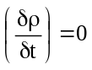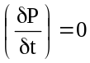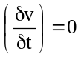
The flow of fluid is said to be unsteady, when the flow characteristics at a point change with time.
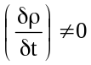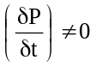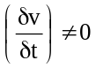
Uniform and non- uniform flow: The flow is said to be uniform, when there is no variation in the magnitude and direction of the velocity from one point to another along the path of the flow (both velocity and area of flow must be same at every cross section) or the velocity does not change along the length of the flow.
A flow of a fluid is said to be non-uniform, when the velocity of flow doesn’t remain constant at all the points in space during a given interval.
Rotational flow is that type of flow in which the fluid particles while flowing along stream lines also rotate about their own mass axis.
Irrotational flow: if the fluid particles while flowing along stream lines do not rotate about their own axis, then it is called irrotational flow.
Compressible flow is that type of flow in which the density of the fluid changes from point to point.
Incompressible flow is one in which the density of the flowing fluid is constant.
One dimensional flow is the flow in which flow parameter such as velocity is a function of time and one space co-ordinate.

Two dimensional flow is one in which flow parameter, velocity is a function of time and two rectangular space co-ordinates.
Three dimensional flow is one in which the flow parameter, velocity is a function of time and three mutually perpendicular space coordinates.
Potential flow : A moving fluid uninfluenced by stationary solid walls is not subjected to shear, and shear stresses do not exist with in it. The flow of incompressible fluid with no shear is called potential flow. Potential flow has two characteristics,
- neither circulation nor eddies can form with in the stream, so that potential flow is also called irrotational flow.
- friction cannot develop, so that there is no dissipation of mechanical energy into heat.
Stream line : For steady flow we can map out the velocity and direction at any point; see figure 2.1, in which the velocity at any point is represented by an arrow showing the relative velocity and direction of the flow.
A
Figure 1.12. Point values of flow velocity and direction for steady, two dimensional flow.
If we follow the history of a fluid particle starting at A, we see that it moves, not in a straight line, but rather along a curve, whose direction at any point is tangent to the flow direction. Such a curve, showing the path of any fluid particle in steady flow, is called streamline. Obviously, there is a streamline passing through every point in the flow; so if all the streamlines were drawn in figure 2.1, the entire flow area would be printed black. Therefore, it is common practice to draw only a few streamlines, from which the intermediate ones can be readily interpolated. In steady flow there is no flow across (i.e., perpendicular to a streamline.
Definition: A streamline is an imaginary curve in a mass of flowing fluid such that the net velocity vector u is tangent to the streamline. No net flow takes place across such a line.
Stream tube: is an imaginary pipe in the mass of flowing fluid through the walls of which no net flow is occurring.
Laminar flow : is defined as that type of flow in which the fluid particles move along well defined paths or stream lines and all the stream lines are straight and parallel. This type of flow is also called stream line flow or viscous flow.
The particles virtually move in one constant direction. They do not posses any velocity in any other directions, with the effect that the particles moving in any one layer restrict to their own layer and do not cross over to any lower or higher layer. This type of flow occurs at low velocities and /or at high viscosities.
Turbulent flow: of a fluid is the flow in which the fluid particles have random motion. The particles do not restrict to their own laminae but they continuously change their layers. The velocity of the particles also changes in magnitude and direction from point to point.
Transitional flow : is the type of flow when there is a change over from the laminar flow to turbulent flow or vice versa.
A criterion to determine the type of flow is the Reynolds number, denoted as N_{re} or Re. It is a non-dimensional number, which is given by the expression.
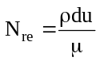where, ρ - density of fluid
d - diameter of pipe
u - velocity of fluid
μ - viscosity of fluid
If the Reynolds number is less than 2100, the flow is laminar. If Reynolds number is more than 4000, it is called the turbulent flow. If the Reynolds number lies between 2100 and 4000 the flow may be laminar or turbulent (transition).
Exercise Problems
1.1. An oil of specific gravity 0.8 is contained in a vessel at a point, the height of oil is 20m, find the corresponding height of water at that point.

1.2. An open tank contains water upto a depth of 1.5m and above it an oil of specific gravity 0.8 for a depth of 2m. Find the pressure intensity ;
- at the interface of the two liquids
- at the bottom of the tank

1.3. An aeroplane is flying at an altitude of 4000 m, Calculate the pressure around the aeroplane, given the lapse rate in the atmosphere as 0.0065K/m. Neglect variation of g with altitude. Take pressure and temperature at ground level as 10.143 N/cm² and 15ºC respectively. The density of air at ground level is given as 1.285kg/m³.

1.4. The atmospheric pressure at the sea level is 101.3 kN/m² and the temperature is 15ºC. Calculate the pressure 8000m above sea level, assuming i) air is incompressible ii) Isothermal variation of pressure and density and iii) adiabatic variation of pressure and density. Assume density of air at sea level as 1.285 kg/m³, Neglect variation of g with altitude.
1.5. The conditions at sea level are 1 atm and 15ºC. Calculate the pressure and temperature at 3500 m according to i) the isothermal atmosphere, ii)isentropic atmosphere.

1.6. An oil of specific gravity is 0.8 under a pressure of 137.2kN/m²
- What is the pressure head expressed in m of water?
- What is the pressure head expressed in m of oil?
1.7. A circular pipe carrying benzene is connected to an orifice meter with a ‘U’ tube manometer for measuring pressure drop across orifice meter. The manometeric fluid is mercury and for a particular flow rate, the reading is 2cm.

1.8. Find out the pressure drop in terms of benzene head. Density and viscosity of benzene are 0.87g/cc and 0.6 cP respectively.

1.9. Determine P_{b} – P_{a} in the figure E 1.1 and express it in terms of meters of oil of relative density 0.80.
A
0.50 m
0.20 m
Water
Carbon tetra chloride
Sp. gr = 1.60
B
A
water
0.5m
0.4m
0.3 m
Oil
Sp. gr. = 0.8
Figure E 1.1.

1.10. A 25cm dia pipe carries oil of specific gravity 0.9 at a velocity of 3m/s. At another section the dia is 20cm. Find the velocity at this section and the mass rate of flow of oil.

1.11. The diameter of a pipe change from 20 cm at a section 5m above datum, to 5 cm at section 3m above datum. The pressure of water at first section is 5*105 N/m². If the velocity of flow at the first section is 1m/s, determine the intensity of pressure at the second section.

1.12. Determine (P_{a} – P_{b}) in figure E 2.2 and express it in kN/m² .

Examination questions and problems
P_{a}
P_{b}
CCl₄
Sp.gr. = 1.60
Oil
Sp.gr. = 0.8
Mercury
Sp.gr. = 13.55
900 mm
700 mm
600 mm
850 mm
Figure E.2
Feb 1995
1.a. Show that the pressure intensity at a point in a static fluid is of equal magnitude in all directions. (6)
b. In the atmosphere temperature falls about 2ºC per 305 m stabilising at -55ºC at (tropopause) top of troposphere. At a place on earth the temperature and absolute pressure are 30ºC and 760 mm Hg. Assuming air as an ideal gas and the above relation being valid through out, calculate the altitude and pressure of tropopause at this place. (14)

2.a. What are the different types of fluids? With the aid of plots explain the shear stress – shear rate behaviour of different fluids.
b. A simple manometer is used to measure the pressure of water flowing in a pipe line. Its right limb is open to the atmosphere and the left limb is connected to the pipe. The centre of the pipe is in level with that of the mercury in the right limb. Determine the pressure in the pipe if the difference of mercury level in two limbs is 10 cm. Densities of mercury and water are 13600 and 1000 kg/m³ respectively.
Aug 1995
3.a. Define
- Newtonian & Non-newtonian fluids
- Absolute pressure
- Viscosity
- Reynolds Number (8)
b. What would be the barometric pressure in bars at an altitude of 1200m, if the pressure at sea level is 1.013 bar. Assume isothermal conditions at 21ºC. (8)
c. A circular pipe carrying benzene is connected to an orifice meter with a U tube manometer for measuring pressure drop across orifice meter. The manometeric fluid is mercury and for a particular flow rate, the reading is 2 cm. Find out the pressure drop in terms of benzene head. Density and viscosity of benzene are 0.87g/cc and 0.6cP respectively. (4)
4.a. Derive the condition of hydrostatic equilibrium and deduce the barometric equation. (8)
Feb 1997
5.a. Explain briefly the following types of flow (8)
(i) Potential flow (ii) Laminar flow
(iii) Turbulent flow (iv) Isentropic flow.
b. What are Non – newtonian fluids? Mention different types of such fluids. (9)
c. Explain briefly, why a good motor oil should be a pseudoplastic fluid (3).
6.a. State pascals law. (2)
b. Write barometric equation. Write also its applications in fluid statics problems.(4)
c. At what height does an isentropic atmosphere have temperature of 0ºK? Assume the surface temperature of air 15ºC and the pressure as 1 atm. The specific heat ratio of air is 1.4. Derive the equation used. (14)

Aug 1997
7.a. Define a fluid. Distinguish between liquids and gases.
b. State Newton’s law of viscosity. With example briefly discuss about Non-newtonian fluids.
c. A needle can float on water if it is placed length-wise on water. Why?
d. Determine the capillary rise in a clean glass tube of internal diameter 2.5mm. The liquid is carbon tetrachloride.
e. Assuming the depth of sea to be 10000m deep, determine the mass density of sea water at this depth, if its specific gravity at sea level is 1.026.
(3+5+3+3+6=20)
8.a. If atmosphere follows isothermal conditions, determine the density and pressure at an elevation of 2000m above sea level, if the mass density of air at atmospheric pressure of 101.325 kN/m², sea level is 1.208 kg/m³.
b. Derive the equation used above.
c. How fluid pressure is measured?
d. What are different types of manometers? Explain any one of them briefly.
(4+7+3+6)
March 1998
9.a. Define
i. Compressible fluids ii. Incompressible fluids
iii. Real fluid iv. Ideal fluid (8)
b. State and prove Pascal’s law (6)
c. What is the device used for measuring fluid pressure? Explain briefly the principle of an inclined manometer.
10.a. State Newton’s law of viscosity. Draw a plot of velocity gradient versus shear stress and discuss the different types of fluid with examples. (8)
b. What is hydrostatic equilibrium? Derive an expression for the condition of hydrostatic equilibrium. (8)
c. Derive barometric equation for an ideal gas. (4)
Sept 1998
11.a. Prove that the pressure and temperature for an adiabatic process at a height z meters from a sea level for a static air are
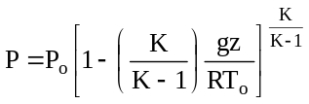 and 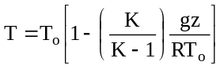, where P_{o} and T_{o} are the pressure and temperature at the sea level. (16)
b. What do you understand by the term ‘Temperature lapse rate’? (4)
12.a. Define Newtonian and Non-Newtonian fluids. (5)
b. What is a manometer? How are they classified? (5)
c. Distinguish between laminar and turbulent flow. (5)
d. An oil of specific gravity 0.9 is contained in a vessel. At a point the height of oil is 40m. Find the corresponding height of water at that point? (5)
Aug 2000
13.a. Define Pascal’s law and prove it. (5)
b. The temperature of earth atmosphere drops about 5ºC for every 1000m elevation above earth’s surface. If the temperature of air at ground level is 15ºC and the pressure is 760mm Hg at what elevation is the pressure 380mm Hg? Assume that the air behaves as ideal gas. Derive the equation used. (15)
March 2001
14.a. Define Newton’s law of viscosity. (3)
b. What are Non-Newtonian fluids? Explain briefly with examples (8)
c. What are the applications of manometers? Explain with neat sketch, working of an inclined U tube manometer. (9)
15.a. State Barometric equations. Derive the same, stating all the assumptions.
(10)
b. At the head of mine, the pressure, density and temperature of the atmosphere are 101kN/m², 1.2kg/m³ and 20ºC respectively. Determine the value of K(specific heat ratio) if the mine is 2000 m deep and temperature increases at the rate of 0.009ºC/m. (10)

Aug 2001
16.a. Show that pressure acting at a point in a fluid, at equilibrium, is uniform in all directions. (6)
b. U-tube manometer is connected across an orifice meter. Derive an expression for the difference in pressure between the two limbs of the manometer. (6)
c. A U-tube manometer filled with mercury, which has a specific gravity of 13.6 is connected to two points of a horizontal pipe. The difference between the levels of mercury in the two limbs of the manometer is 50mm. What is the difference between the pressures at these points if the fluid flowing through the pipe is (i) water; and (ii) air at 25ºC and 110 kPa? (8)
17.a. Explain the shear stress – shear rate behaviour of different types of fluids.(6)
b. Explain briefly the boundary theory. How separation of boundary layer can be prevented?
c. Explain Reynolds experiment and hence define Reynolds number. Explain the significance of the same. (8)
Model question paper – 1
18. a. Define:
i. Newtonian and non – Newtonian fluids ii. Laminar and Turbulent flow
iii. Reynolds number iv. Fully developed flow. (4*2=8)
b. A simple U tube manometer contains mercury. When 11.2 cm of water is poured into the right limb how high does the mercury rise in the left limb form its initial value? (4)
c. If the velocity in the x direction is V_{x} = a(1-by²) where y is perpendicular to x, show that the shear stress is linear. (4)
d. If atmosphere follows isothermal conditions, determine the density and pressure at an elevation 2000m above sea level, if the mass density of air at atmosphere of 101.325 kN/m², at the sea level density is 1.208 kg/m³. (4)

Model question paper – 2
19.a. Explain the different non-Newtonian fluids with suitable examples.
b. What is meant by hydrostatic equilibrium? Derive an expression for it and deduce barometric equation from it.
20.a. Define the term Manometry. Describe the working of a differential manometer.
b. The temperature of earth’s atmosphere drops by about 5ºC for every 1000m of elevation above earth’s surface. If the air temperature at the ground level is 290K and the pressure 1.013*10⁵N/m² at what elevation is the pressure 4.05*10⁴ N/m². Assume that the air behaves as an ideal gas.
Aug2002
21. b. Prove that “the intensity of pressure at any point in a fluid at rest, is same in all direction”. (6 Marks)
22. a. Explain with sketches the different types of manometers, used for measuring pressures. (12Marks)

